Corrections – 1 – Sept. 2026

From there the following job category of “jobstring” came from?

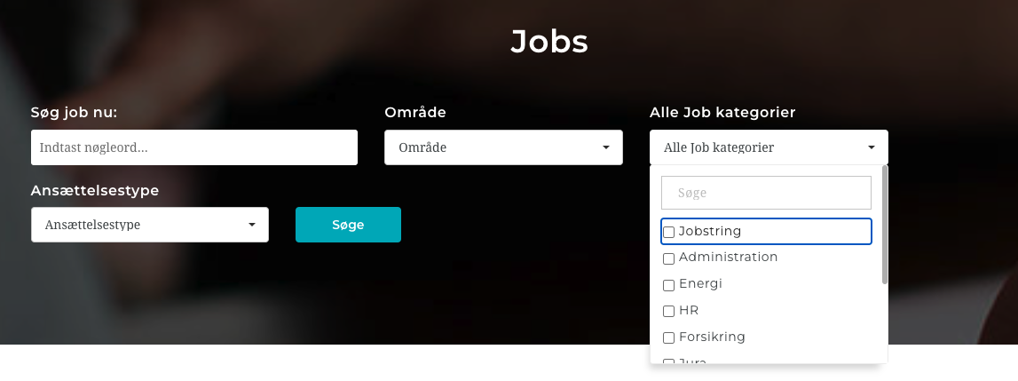

Cant check the following as my account has highest package assigned already and there is no way being offered to down grade it, can you clarify how the company with highest available packaged will down grade?:

The option of ”Cash on Delivery” under the payment option /under stripe must be removed.

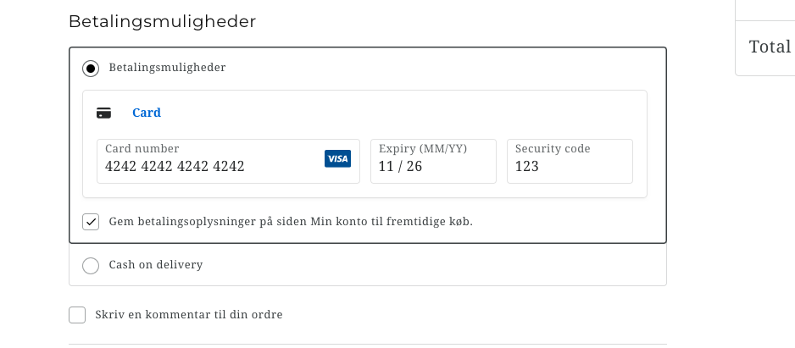

Also why stripe does not give the list of CARD CATEGORIES to Select From, you will see below 2 images, 1st from Job String and other from any random online shop:

------------

How are we going to figure out for which job a candidate has applied, it does not give name of the job applied for,………… Along with the category of the field, there must be a reference to specific job applied for……I can see you have created an other page with the name of job applications but the number of applications must reflect in connection with a particular job (if the application are for the claims handler job, they must be enlisted under that job)………

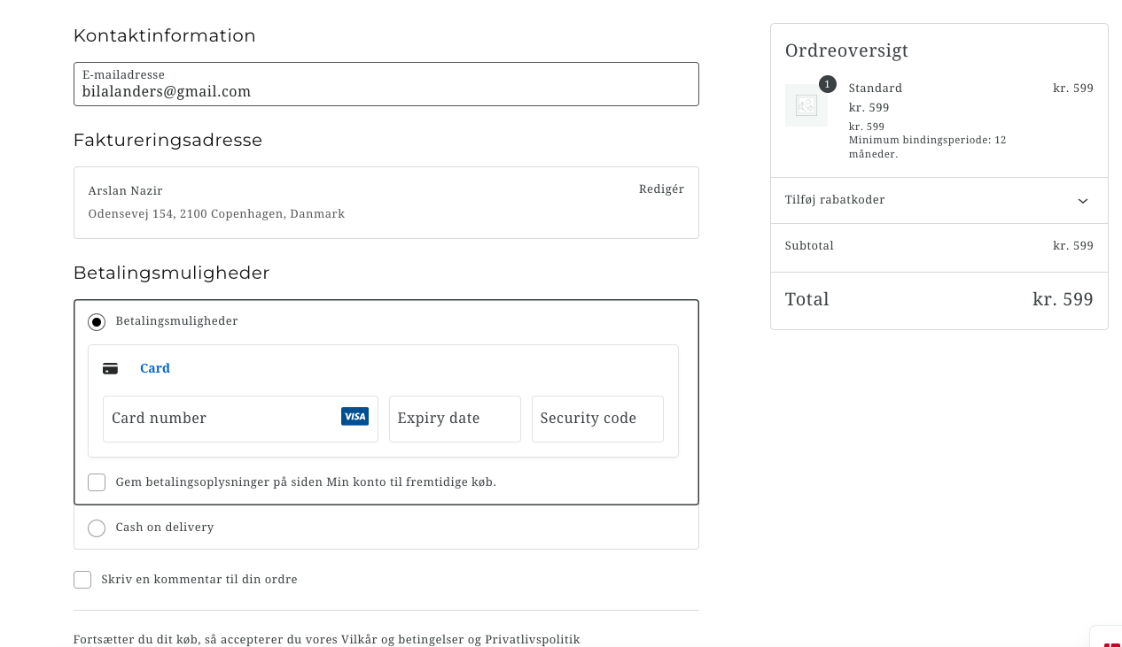

----
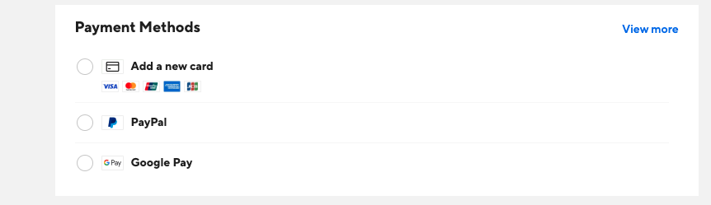
…………..

Similarly if the employer is already using the highest option (premium) he cannot upgrade his package to lower options, so the wording must change accordingly or must replace the word “upgrade” with that of “select the option” on the following page: call me if you don’t follow

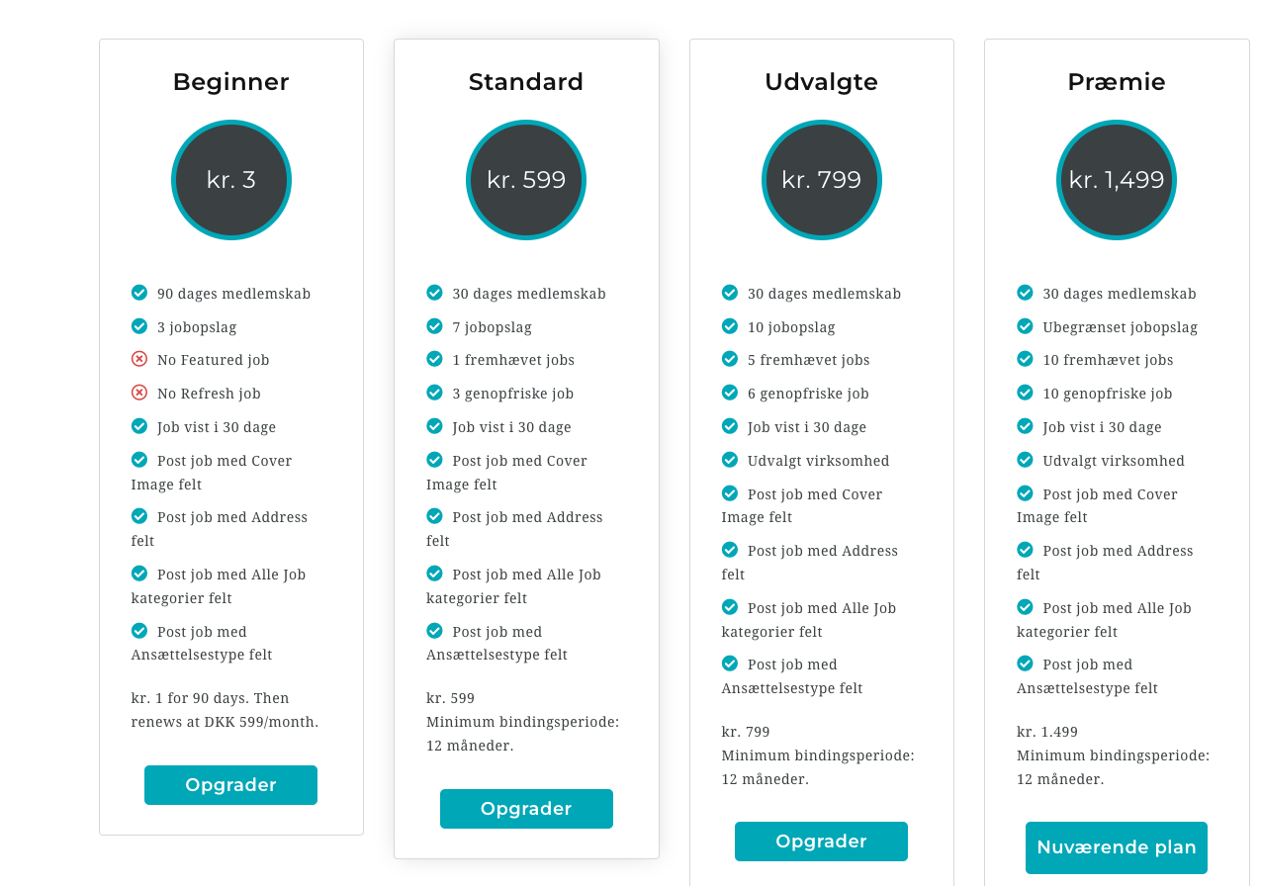

………….

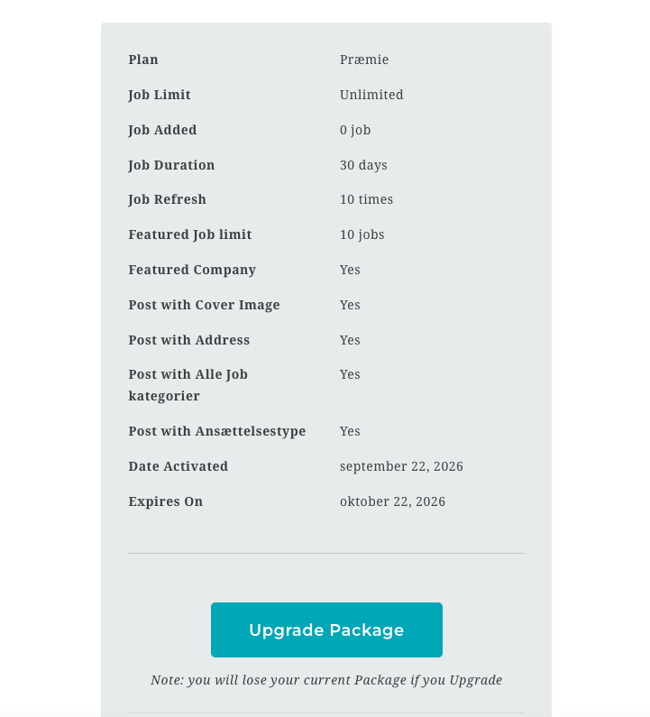

The above is already highest package available, how can on upgrade it / it can only be down graded…………………..Also see the comments in the bottom is in English….

When I click to upgrade (upgrade wording is wrong wording, as mentioned before you can’t upgrade a thing to lower grade) this is what appears, does not make much sense to write “highest plan active” under all options….. first three options must simply not be available for those who already are maintaining highest plan, and as requested before, there must be 6 months binding period for any particular plan (unless you wish to upgrade, in which case company can upgrade to a higher plane right away)…. In simple words: NOT DOWN grading from a higher plan can be allowed without completing 6 months binding period BUT upgrading can be down right away with the payment of fee required for higher package……

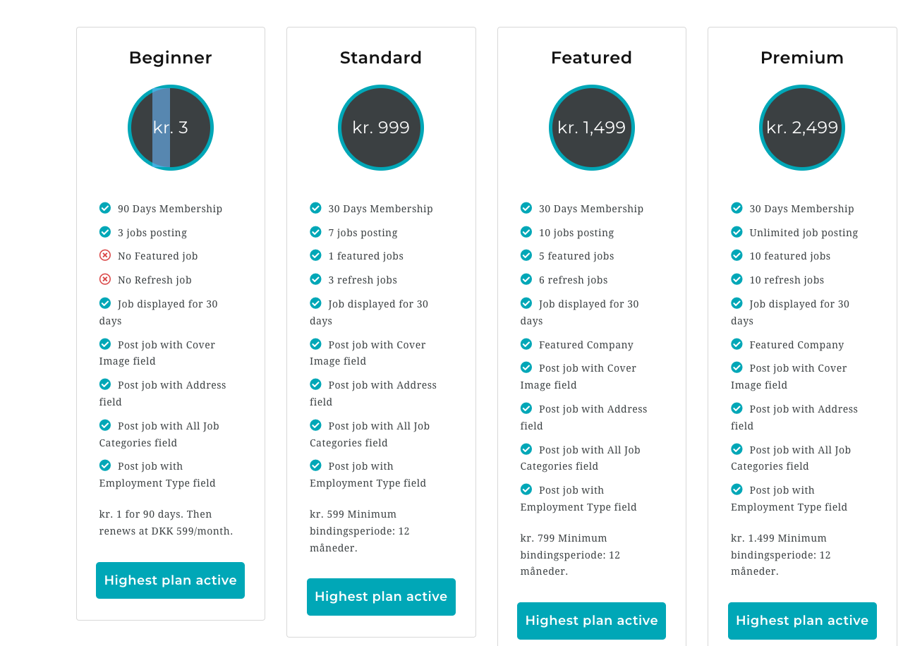

Also see below, it still showing the same wording of “upgrade package”……

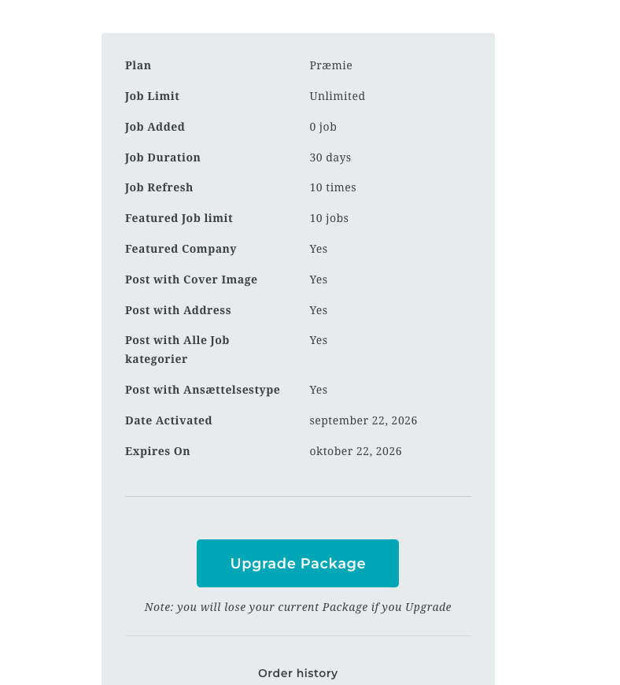

Also read the note under the wording Upgrade package, does it make any sense to you?
--------

While giving the job add, the last option is to divert the job applicant to the page where he will apply for the job (submit his CV, cover letter and other documents)……… I can’t see as to how it will be diverted to JOBSTRING if the job is to be applied via our website and the information is to be stored on our server under the employer’s dashboard (under the job application and other categories), please clarify / explain?
I still can’t see as to how the company will chose from the following 2 options:

Divert to their website for direct application to them; OR
Receive the application on our website:

PLEASE CLARIFY? were you not working on it?? The below is the new print screen for the job add page…… I can’t see any difference as compare to what we had previously…..

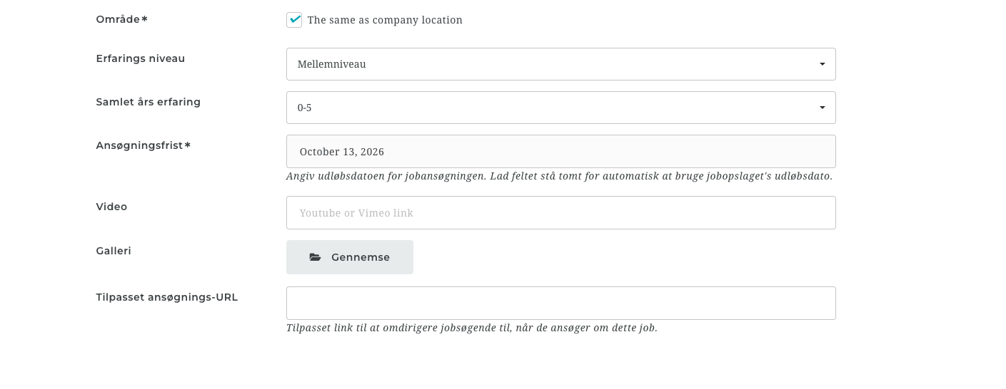
This is the print screen from the admin section where add will be approved before publishing: Why can’t I see the option of applying on our websit??

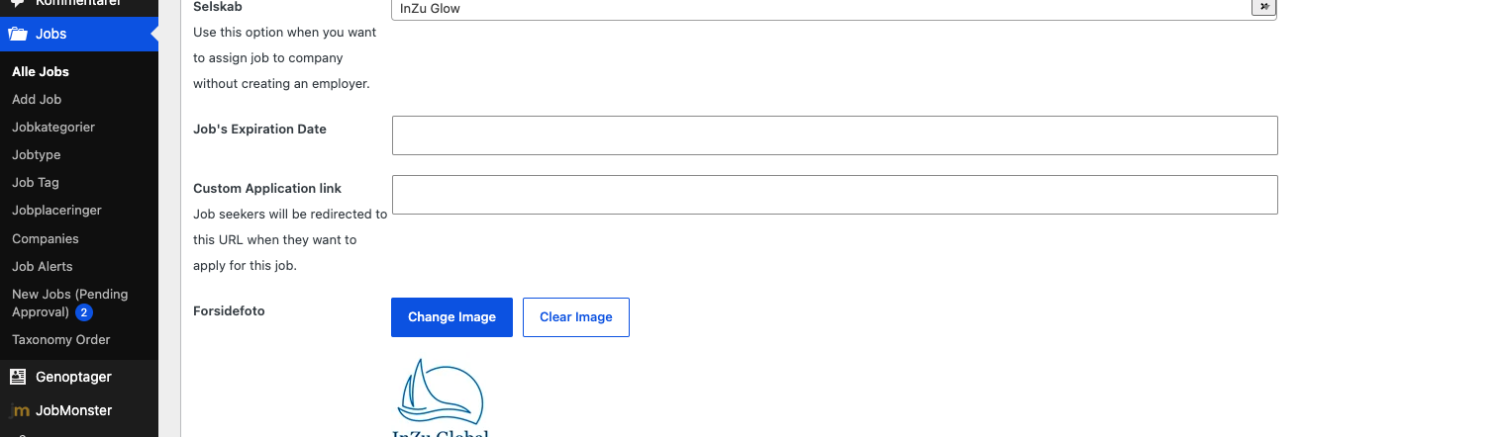

If the application will come to our website bu not entering any link in the above section, the the wording may be replaced with that of the following (in front of “Custom Application Link”:

“If you wish job seekers to apply on company’s website, add direct link here. Don’t fill it if you wish the application to come on Jobstring’s website.”
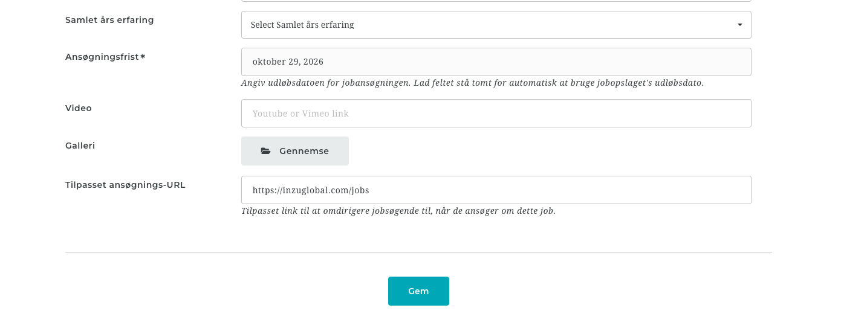
I can remember previously the option was available to send application as a guest and send the same to our website, which you apparently have removed……..

Now there is no option to apply for the job as a guest (of course after accepting our terms and conditions and privacy policy) but why have you removed the option?

We have to fix the above issues before we move forward to check anything else……. Please call me when you have time today…..

……………..

I applied for the job (office assistant without login as a candidate, while my email is connected with a registered provide, it did not object and let me apply as a guest while using the same email which is already registered on our website……….. Can you consider using a “check” to make sure registered users can’t apply as a guest?), which I published and approved today) on the platform and attached 3 documents, while I can only see and download ONLY ONE, see below print screen: where did other 2 documents go?

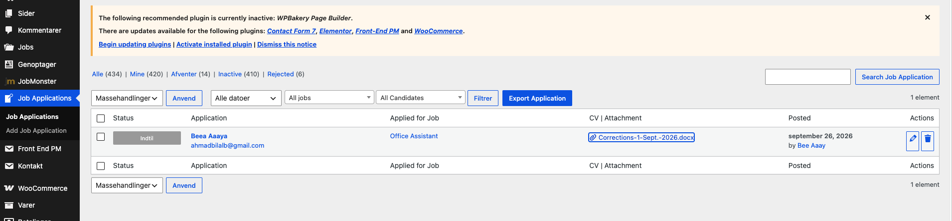

Same with this job application as a Legal Counsel, applied with 3 attachements, can’t see the other two (cover letter and additional document can’t be found anywhere).

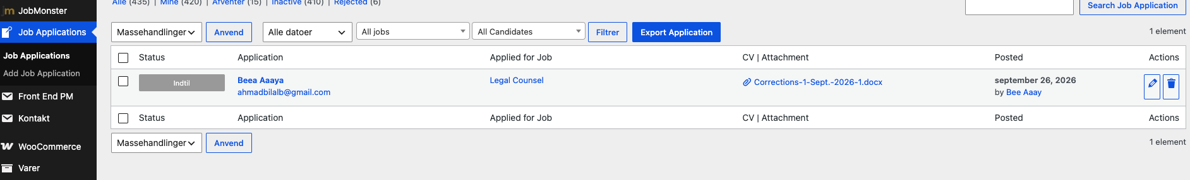

Again used the same email address which is already registered on the website and the website did not ask me to lonin as the email address is connected to a registered account on our website, please see how can you add this security check to ensure no one is using someone else’s email address to apply for a job……….. I was thinking that even the guest must confirm his email address before applying for a job as a guest….. Please look into it….

---------------

Please also see how the following section can be more specific (because if we will be receiving 1000 applications a day, it would be a night mare to figure out whoe applied for which company)………. I think the list of applications must be listed in two ways:

Company wise (all applications must be listed in a company folder with the following heading: job title, date of application, candidate’s email, attached documents, comments)

Jobwise (all applications must ALSO be listed in a Jobwise folder with the following heading: Company name, job title, date of application, candidate’s email, attached documents, comments)

The above two categories will create check and balance on receipt of applications and handling of the same by the relevant staft……..

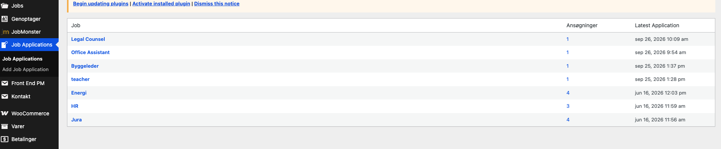

……………………

Lets fix the above first before we move on to other things. Pls call me at anytime in you want any clarifation on the above…….

